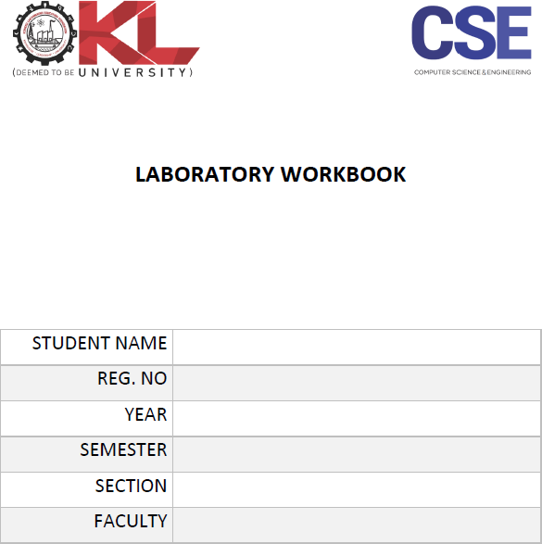

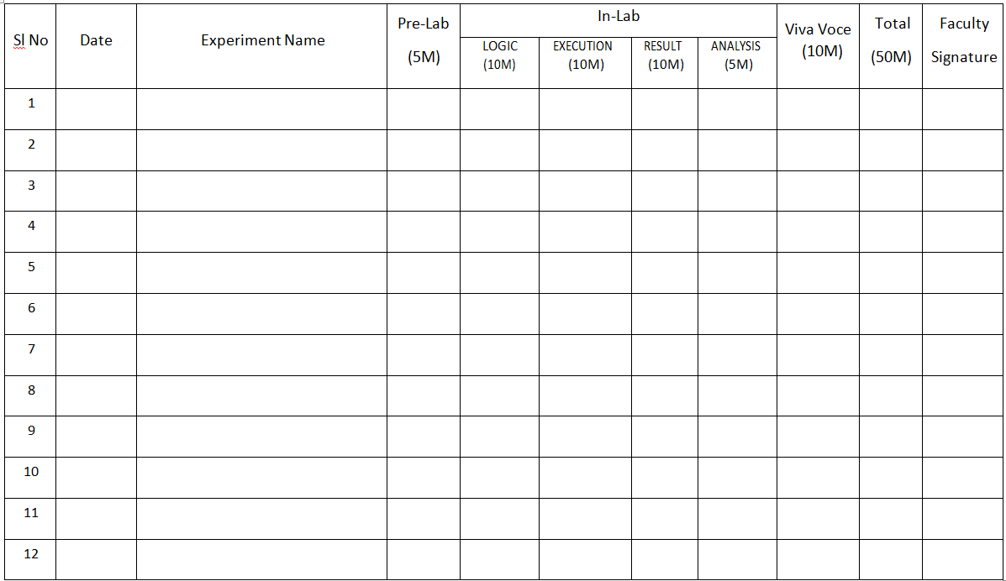

|  |  |  |
| --- | --- | --- |
| **Lab session no** | **List of Experiments** | **CO-Mapping** |
| 1 | How to design test cases. | CO5 |
| 2 | Introduction to J Unit tool | CO5 |
| 3 | Design test case for C program gaming on moving objects. | CO5 |
| 4 | Introduction of QTP tool with flight Applications. | CO5 |
| 5 | Identify the test cases for user interface. Prepare formal documentation. | CO5 |
| 6 | Use of Selenium tool. Using Selenium complete Apparal project. | CO5 |
| 7 | Consider ATM System/Library management system study system specifications and generate report for the various bugs. Introspect the causes for its failure and write down the possible reasons for its failure. | CO5 |
| 8 | Introduction to TestNG tool | CO5 |
| 9 | Introduce Winrunner, Checking GUI Objects using Winrunner for flight application. | CO5 |
| 10 | Cucumber | CO5 |
| 11 | Testing Documentation for Android Application | CO5 |

# Lab Session01: Generate test cases for Addition of two numbers and

# Simple calculator Program.

**Date of the Session: / / Time of the Session: to**

**Title of the Program:**

Generate Test Cases.

**Pre Lab Task:**

Answer the following question before entering into lab. The following pre lab task has to perform at home.

1. Define the term Test Case? What is a good test case in software testing?
2. [Why test cases are so important?](https://blog.e-zest.com/why-test-cases-are-so-important/)
3. List out the different types of test cases?
4. Define Test procedure?
5. List out and explain the rules of writing test cases.

## In Lab Task

1. Design, develop, code and run the program in any suitable language to implement the addition of two numbers. Analyze it from the perspective of equivalence class value testing, derive different test cases, execute these test cases and discuss the test results.
2. Design, develop, code and run the program in HTML to implement the Simple Calculator program. Analyze it from the perspective of equivalence class value testing, derive different test cases, execute these test cases and discuss the test results.

## Post Lab :

## Generate test case to check for Palindrome Number in C Program

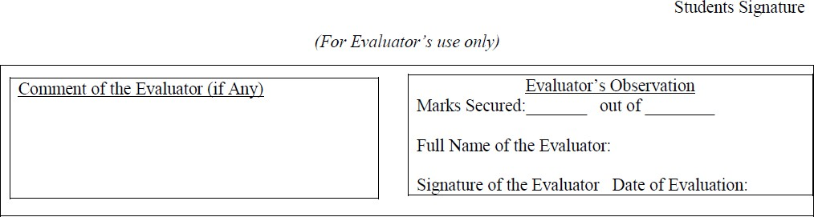

# Lab Session02: Implement unit testing using JUnit unit tests

**Date of the Session: / / Title of the Program:**

**Time of the Session: to**

Introspect the causes for any test failure and write down the possible reasons for its failure.

**Pre Lab Task:**

Answer the following question before entering into lab. The following pre lab task has to perform at home.

1. What is unit testing?
2. **What is Parameterized test in JUnit and what all annotations used for this?**
3. **How @Test annotation is used for testing exceptions?**.
4. How can you setup JUnit?
5. How to run JUnit tests in Eclipse??
6. How to use JUnit?
7. Explain about Testing start process and stop process.
8. Comment on Test strategy

## In Lab Task

1. Design, develop, code and run the program in JAVA to implement the Simple addition and multiplication program. Analyze it from the perspective of equivalence class value unit testing, derive different unit test cases, execute these test cases and discuss the test results.

1. Design, develop, code and run the program in JAVA to implement the Simple array program i.e. (a).remove duplicates in array elements. (b). sum of array elements. Analyze it from the perspective of equivalence class value unit testing, derive different unit test cases, execute these test cases and discuss the test results.

## Post Lab

## Generate Test case for Random Numbers using JUnit



# Lab Session03: Design test case for gaming on moving objects.

**Date of the Session: / / Title of the Program:**

**Time of the Session: to**

Introspect the causes for any test failure and write down the possible reasons for its failure.

**Pre Lab Task:**

Answer the following question before entering into lab. The following pre lab task has to perform at home.

1. What are the objectives of testing?
2. Explain the different sources from which test cases can be selected?
3. Explain the concept of an ideal test.
4. How to design test case? List down the different steps?
5. Name the different tools used for Testing?
6. What Is a Good Test Case?

## In Lab Task

1. Design, develop, code and run the program in any suitable language to implement the Simple Game program. Analyze it from the perspective of equivalence class value testing, derive different test cases (i.e. boundary value analysis), execute these test cases and discuss the test results.

## Post Lab

# Design, develop, code and run the GUI program in any suitable language to implement the Simple Intelligent location identification and passenger-alert system in Indian Railways. Analyze it from the perspective of equivalence class value testing, derive different test cases, execute these test cases and discuss the test results.



# Lab Session04: Introduction of QTP/UFT tool with flight Applications.

# 

**Date of the Session: / / Title of the Program:**

**Time of the Session: to**

Introspect the causes for any test failure and write down the possible reasons for its failure.

**Pre Lab Task:**

Answer the following question before entering into lab. The following pre lab task has to perform at home.

1. What is UFT?
2. Give some object examples in web based environment?
3. Explain the Installation process of UFT.

## In Lab Task

1. Introduction of QTP/UFT tool with flight Applications

## Post Lab

Understand Test Results in QTP/UFT with Print/Export Example

